Personal Finance Chatbot: Intelligent Guidance for Savings, Taxes, and Investments
Project Description:
The “Personal Finance Chatbot” is an intelligent AI-driven financial assistant designed to help users manage their budgets, spending habits, and saving goals with ease. It uses a fully guided form-based interface that eliminates the need for technical inputs or JSON, making financial planning accessible to everyone. The system supports Indian Rupees (₹) and visualizes expenses using charts and summary cards for quick understanding. A dual-model architecture powers the platform where IBM Granite handles conversational guidance, offering empathetic, persona-based responses, while Groq Llama models generate structured calculations, budget summaries, and spending insights with reduced hallucination. Users can interact through a chat interface to ask questions or receive personalized recommendations based on their profile. The platform includes dynamic spending tables to capture real categories like rent, UPI transactions, groceries, and travel. Optimized for development on 8GB laptops using a mock fallback model, the chatbot remains lightweight yet powerful. Overall, it empowers individuals to make informed financial decisions with clarity, confidence, and personalized direction.
Scenarios:
Scenario 1: A user enters their income and monthly expenses using the structured form with fields for salary, rent, groceries, and transportation. The system automatically converts this data into a financial summary in Indian Rupees (₹). It highlights total spending, savings potential, and percentage breakdown by categories with charts and recommendations.
Scenario 2: A student types, “How can I save ₹3000 each month without stopping outings?” into the chat interface. IBM Granite responds with friendly advice tailored to the student persona, suggesting lifestyle adjustments, budgeting tricks, and realistic ways to save without sacrificing enjoyment.
Scenario 3: Users add expense items like UPI payments, shopping, fuel, and food delivery into a dynamic table. Groq analyzes their spending to detect red flags such as excessive delivery charges or high transport costs compared to income. The system displays warnings, top spending categories, and improvement suggestions through visual and textual insights.
Scenario 4: A working professional enters a goal like saving ₹1,00,000 for a laptop. Based on their current income and spending data, the system calculates how much they need to save monthly and whether their current budget supports the goal. It then provides actionable steps to reduce spending and speed up achieving the target.
Scenario 5: Users may just wish to discuss their financial concerns, such as stress about spending or doubt about saving. In addition to helping customers find answers, the chatbot can provide a comforting and useful conversational response that makes them feel heard and supported.

Technical Architecture:
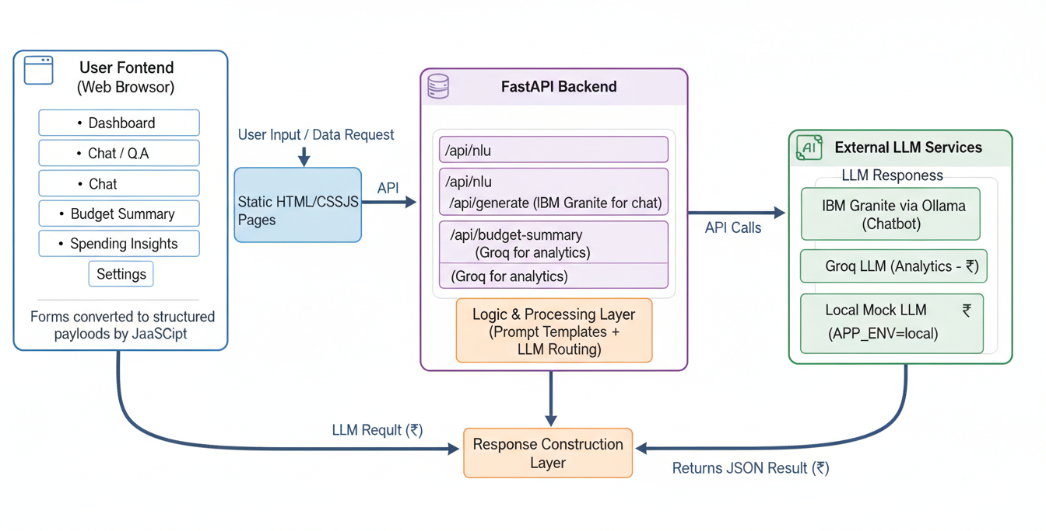
Project Folder Structure:
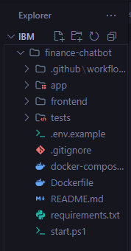
Pre-requisites:
- Python Programming – https://docs.python.org/3/
- FastAPI Integration - https://fastapi.tiangolo.com/
- Groq LLM API (for analytics) – https://console.groq.com/docs
- IBM Granite via Ollama (for chatbot) – https://ollama.com/library/granite
- Ollama Runtime Setup – https://ollama.com/download
- Vanilla HTML/CSS/JavaScript – https://developer.mozilla.org/en-US/docs/Web
- Chart.js for Data Visualization (CDN) – https://www.chartjs.org/docs/latest/
- Pydantic for Data Validation – https://docs.pydantic.dev/latest/
- Uvicorn ASGI Server – https://www.uvicorn.org/
- Environment Configuration (.env) – https://pypi.org/project/python-dotenv/
Project Workflow:
Milestone 1: Multi-Model Selection & Architecture Setup
- Activity 1.1: Ollama Installation and IBM Granite Integration
- Activity 1.2: Select IBM Granite for chatbot and Groq for analytics.
- Activity 1.3: Define dual LLM routing system based on use-case and APP_ENV.
- Activity 1.4: Configure environment variables and secure credential handling.
- Activity 1.5: Set up development environment with mock model support.
Milestone 2: Backend Feature Development
- Activity 2.1: Implement FastAPI routes for chat, budget summary, and spending insights.
- Activity 2.2: Build Pydantic request/response models for structured JSON.
- Activity 2.3: Create prompt templates enforcing JSON-only logic with INR formatting.
- Activity 2.4: Integrate LLM routing layer to select Granite/Groq/Mock dynamically.
Milestone 3: Main App Logic & Processing
- Activity 3.1: Implement logic to parse and validate input from frontend forms.
- Activity 3.2: Process budget and spending data into analytics-ready structures.
- Activity 3.3: Build response construction layer for charts, INR formatting, and savings metrics.
- Activity 3.4: Handle persona-aware chat responses using Granite.

Milestone 4: Frontend UI Development
- Activity 4.1: Build HTML/CSS/JS pages for Dashboard, Chat, Budget Summary, Spending Insights, and Settings.
- Activity 4.2: Implement form handlers to convert inputs into structured API payloads.
- Activity 4.3: Render responses as summary cards, tables, and Chart.js visualizations.
- Activity 4.4: Format all currency output to INR with Intl.NumberFormat.
Activity 5: Deployment & Optimization
- Activity 5.1: Set up production deployment for FastAPI backend and static hosting for frontend.
- Activity 5.2: Configure secure environment variables for Groq and Granite keys.
- Activity 5.3: Optimize performance using streaming, request timeout handling, and caching.
- Activity 5.4: Final testing with mock, local, and production modes.
Activity 6: Conclusion

Milestone 1: Multi-Model Selection & Architecture Setup
- Activity 1.1: Ollama Installation and IBM Granite Integration
- Installing Ollama: To enable local execution of the IBM Granite model for the chatbot component, Ollama is used as a lightweight model runtime. Ollama runs on the local machine as a background service and exposes a simple HTTP API that the backend can call.
Installation steps (high level):
- Download and install Ollama
  - Visit the official Ollama website and download the installer for your operating system.
  - Complete the installation wizard, which sets up the Ollama runtime and CLI.
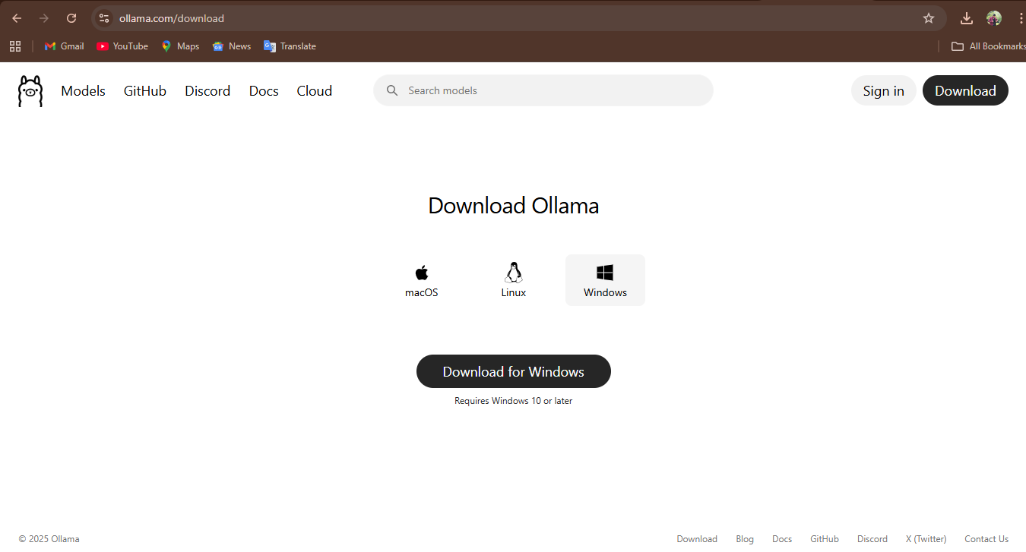
- Verify the installation
  - Open a terminal and run:
ollama -v
  - If the command prints a version number, the installation is successful.

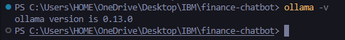
- Start the Ollama service
  - On most systems, Ollama starts automatically.
  - You can verify it is running by calling:
  - curl http://localhost:11434
  - A valid response confirms the service is ready to accept model requests.

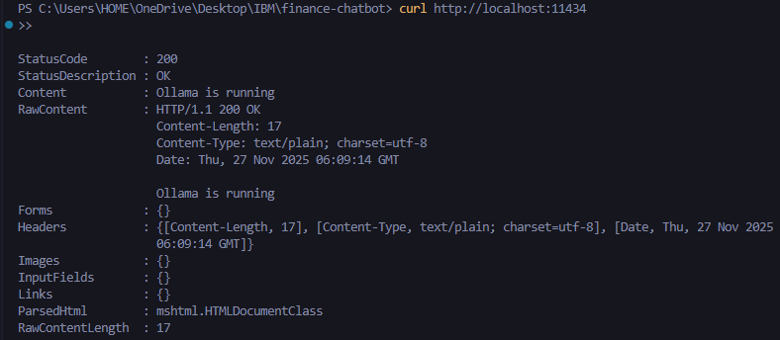

- Choosing and Pulling the Granite Model in Ollama: The chatbot uses an IBM Granite-based model hosted inside Ollama. The choice of model is based on a trade-off between quality, latency, and hardware limits.
- Model selection criteria
  - Model size and hardware constraints: For local development on an 8 GB RAM laptop, a smaller Granite variant or a quantized model is preferred to keep memory usage reasonable.
  - Use case: Since Granite is used only for conversational Q&A (not heavy numeric analytics), a medium-sized instruction-tuned Granite model is sufficient for natural, persona-aware answers.
- Pulling the Granite model
  - Once Ollama is installed, a specific Granite model is downloaded (pulled) using the Ollama CLI.
  - Example (model name is just illustrative; the exact tag is chosen from the Ollama model library):
  - ollama pull granite:latest
  - This command downloads the Granite model weights and makes them available for inference through the Ollama runtime.
- Configuring the model name for the project
  - The chosen Granite model name is stored in an environment variable, for example:
GRANITE_MODEL_NAME=granite3.1-dense:8b

- Integrating Ollama + Granite with the FastAPI Project: The integration between the FastAPI backend and Ollama is encapsulated in a dedicated model client so that the rest of the code remains model-agnostic.
- Runtime configuration via environment variables
  - Two key variables are used to connect to Ollama and Granite:
  - OLLAMA_API_URL=http://localhost:11434
  - GRANITE_MODEL_NAME=granite:latest
  - APP_ENV controls whether this Granite client is used (in prod) or replaced by the mock client (in local).
- Granite client implementation
  - In app/models/ollama_granite.py, a client class (e.g., GraniteClient) is implemented with a standard interface:
  - async def generate(self, prompt: str, max_tokens: int = 512, stream: bool = False) -> str:
  - ...
  - This method internally sends an HTTP POST request from FastAPI to the Ollama API endpoint, specifying:
    - the model name (GRANITE_MODEL_NAME),
    - the prompt (chat message),
    - optional generation parameters (max tokens, temperature, etc.).
- Routing logic for when Granite is used
  - The project uses a routing helper (e.g., get_llm_client(purpose: str)) in llm_service.py.
  - For the chatbot endpoint (/api/generate), the purpose is set to "chat". When APP_ENV=prod, this purpose maps to the GraniteClient which calls Ollama.
  - For budget and spending analytics, the routing directs requests to the Groq client instead, ensuring Granite is only used for conversational responses.
- Using Granite in the chatbot workflow
  - When a user submits a question on the Chat page, the frontend sends a request to /api/generate.
  - The FastAPI route:
    - builds a persona-aware prompt,
    - calls the GraniteClient.generate() method,
    - and returns the model’s answer as structured JSON.
  - The frontend then displays this result in the chat UI as a response bubble.
- Mock model behavior for local development
  - When APP_ENV=local, the routing function returns a mock client instead of the Granite client, even though the integration code remains the same.
  - This allows the entire Granite workflow (prompt creation → generate() call → response parsing) to be tested without actually starting Ollama on every developer machine.
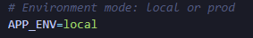
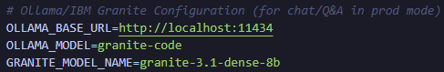
- Activity 1.2: Select IBM Granite for Chatbot and Groq for Analytics
- Understand requirements for diverse financial tasks: The project needs a model that can handle friendly conversational responses and a different one that can deliver accurate numeric analysis for budgets and spending summaries.
- Analyze model strengths based on task type: IBM Granite (via Ollama) is highly suitable for persona-aware, empathetic, and long-form conversational responses that sound natural and user-specific.
- Choose analytical model for strict financial reasoning: Groq models excel at fast, structured numeric evaluation and produce JSON-formatted responses ideal for budgets and spending insights. Thus, Granite is selected for chat and Groq for analytics.

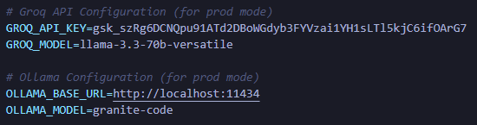

- Activity 1.3: Define Dual LLM Routing System Based on Use-Case and APP_ENV
- Classify system operations by purpose: Divide backend calls into specific “purposes” such as chat, budget_summary, and spending_insights so the correct model can be chosen automatically.
- Implement routing logic for production: When APP_ENV=prod, chatbot requests are routed to IBM Granite, while financial analytics are routed to Groq, ensuring each model handles its specialized task.
- Implement routing logic for local development: When APP_ENV=local, all operations use a lightweight mock LLM, enabling development without GPU or internet-based inference and reducing cost and latency.

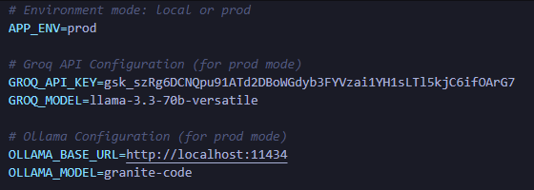

- Activity 1.4: Configure Environment Variables and Secure Credential Handling
- Store sensitive data securely in environment files: API keys and URLs such as GROQ_API_KEY, OLLAMA_API_URL, and GRANITE_MODEL_NAME are stored only in .env files, not in source code.Install FastAPI, Uvicorn & Streamlit
- Load credentials dynamically at runtime: The backend retrieves keys using libraries like python-dotenv, ensuring clean separation between code logic and configuration.Set Up the Personal Finance
- Maintain separate environment setups: Provide .env.example for developers and allow different .env files for local, staging, and production deployments without modifying the application code.

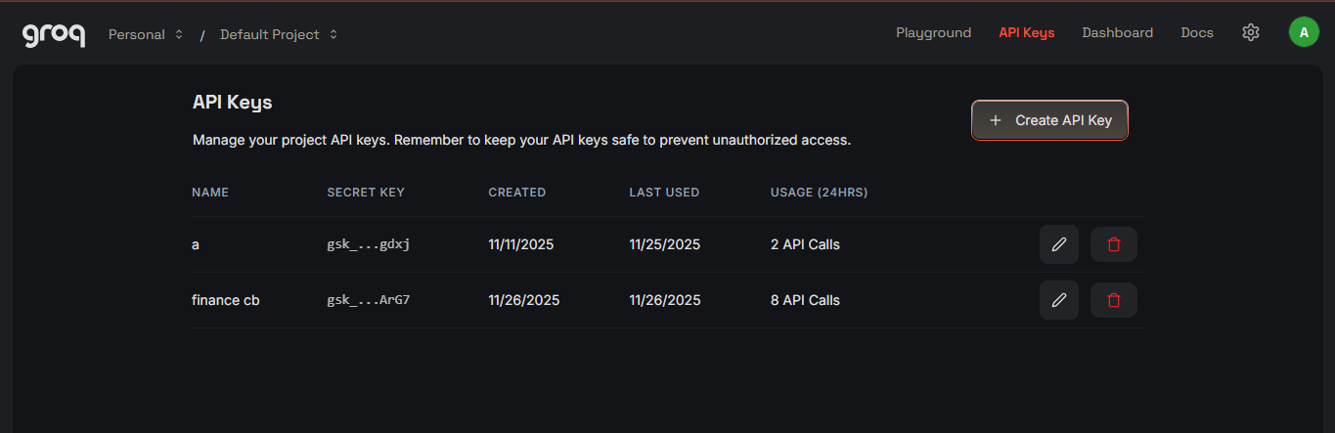

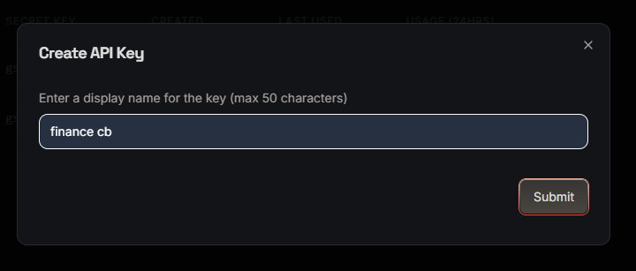

- Activity 1.5: Set Up Development Environment with Mock Model Support
- Initialize backend development environment: Create a Python virtual environment, install dependencies using requirements.txt, and configure FastAPI with reload mode for quick changes during development.
- Implement fallback mock model: A fallback_mock client is developed to return predictable JSON outputs so developers can test UI screens, charts, and flows without calling external LLMs.
- Enable smooth testing on low-spec laptops: Running on an 8GB system becomes efficient since mock inference requires no GPU or heavy API calls, allowing the entire UI + backend pipeline to be built first before switching to real Granite and Groq models.

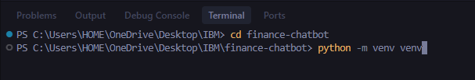

Milestone 2: Backend Feature Development
- Activity 2.1: Implement FastAPI Routes for Core Features
- Define core API endpoints: Design dedicated routes for /api/generate, /api/budget-summary, and /api/spending-insights so that each financial feature has its own clear, maintainable entry point in the backend.
- Organize routes into modular files: Group related endpoints into separate router modules (e.g., routes_generate.py, routes_budget.py, routes_insights.py) to keep the codebase clean and aligned with single-responsibility principles.
- Enable automatic API documentation: Integrate these routes with FastAPI’s automatic OpenAPI generation so that interactive docs at /docs or /redoc can be used for quick testing and debugging.

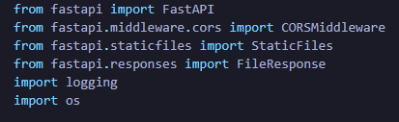

- Activity 2.2: Build Pydantic Models for Structured Request and Response
- Define request models for each feature: Create Pydantic classes for chat requests, budget inputs, and spending insights (including fields like income, category, amount, currency, and persona) so that invalid data is rejected at the API boundary.
- Design response models with clear schemas: Specify response models that include fields such as answer, total_income, total_expenses, savings_rate, top_categories, and recommendations so that the frontend always knows what to expect.
- Leverage validation for safer LLM integration: Use Pydantic validation not only for user input but also when parsing JSON from LLM outputs, ensuring that malformed or hallucinated data is caught before being sent to the UI.

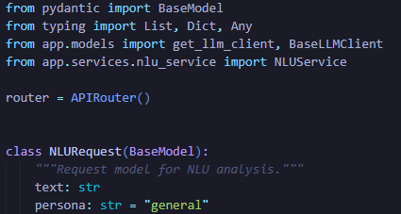
- Activity 2.3: Create JSON-Only Prompt Templates with INR Context
- Design strict prompt templates with schemas: For budget summary and spending insights, write prompts that clearly specify the required JSON schema and explicitly instruct the LLM: “Output MUST be valid JSON only, with no extra text.”
- Embed INR and persona context in prompts: Include cues such as "currency": "INR" and persona hints (student, professional) inside the prompt so that the model tailors responses to Indian users and their financial situations.
- Reduce hallucinations via examples and constraints: Add example JSON outputs and instructions like “If a value cannot be computed, set it to null” to keep the model within safe, verifiable bounds and easier to parse programmatically.

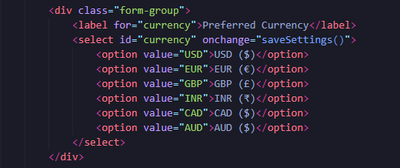

- Activity 2.4: Integrate LLM Routing Layer for Granite, Groq, and Mock Models
- Implement purpose-based routing function: Create a helper such as get_llm_client(purpose: str) that selects Granite for chat, Groq for budget_summary and spending_insights, and a mock model when in local development mode.
- Read APP_ENV and model configs from environment: Ensure the routing logic reads APP_ENV, API keys, and model names from environment variables so configuration can change without modifying code.
- Decouple routes from specific model implementations: Make API handlers call only the routing interface, not direct model clients, allowing the underlying LLM provider to be swapped or extended with minimal code changes.

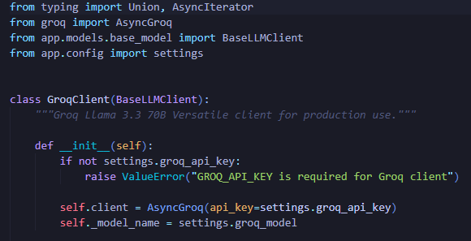

Milestone 3: Main App Logic & Processing
- Activity 3.1: Parse and Validate Inputs from Frontend Forms
- Convert form submissions into structured payloads: On the backend, expect already-structured JSON created by the frontend from form inputs, and ensure all required fields like categories, amounts, and currency are present.
- Handle missing or inconsistent values gracefully: Provide default values or user-friendly error responses when fields are missing, such as zero amounts or unsupported categories, instead of crashing the pipeline.
- Ensure compatibility with LLM prompt construction: Normalize all numeric data and text fields into a consistent internal structure so prompt templates can be built reliably for Groq and Granite.

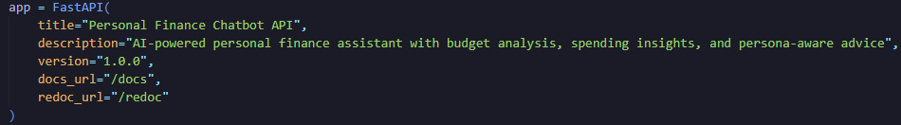

- Activity 3.2: Process Budget and Spending Data into Analytics-Ready Structures
- Aggregate financial totals and category sums: Compute total income, total expenses, and per-category sums before calling the LLM so core numbers are already correct and not left to the model to infer.
- Derive additional metrics server-side: Calculate metrics like savings rate, surplus, and category percentages to reduce model workload and ensure deterministic financial figures.
- Prepare structured context objects for prompts: Build clean dictionaries representing the user’s financial situation and pass them into templates as JSON so the LLM focuses mainly on interpretation and recommendations.

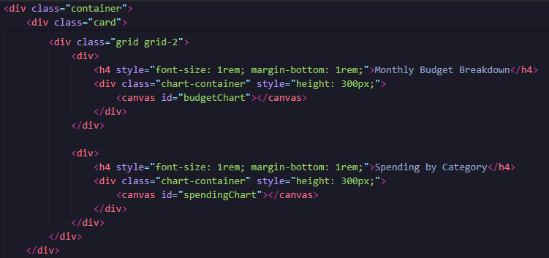
- Activity 3.3: Build Response Construction Layer for Charts, INR, and Insights
- Transform LLM JSON into frontend-friendly format: Parse the LLM’s JSON response and reshape it into structures suitable for cards, tables, and Chart.js datasets (labels, values, colors).
- Apply INR formatting before sending to UI: Ensure the backend or frontend consistently represents monetary values in Indian format (e.g., 1,00,000) to maintain clarity for users.
- Attach meta-information for transparency: Include fields like model_used, persona, and timestamp in the response so that debugging and audit trails are easier.

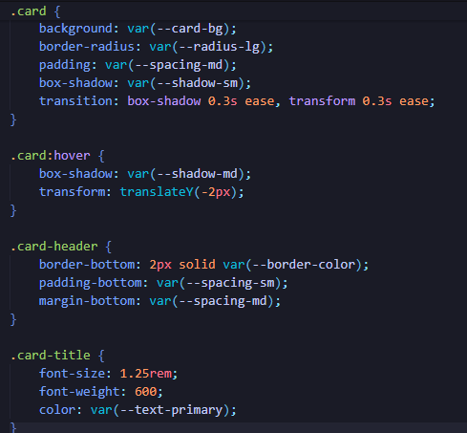

- Activity 3.4: Handle Persona-Aware Chat Responses Using IBM Granite
- Incorporate persona into chat prompts: Pass persona labels such as “student” or “professional” into Granite prompts so the tone, complexity, and examples match the user’s profile.
- Balance empathy with financial accuracy: Design prompts that instruct Granite to be supportive and clear, but still grounded in realistic financial advice and not over-promise results.
- Structure responses for frontend display: Return chat messages in a consistent JSON structure (e.g., {"answer": "...", "model":"granite"}), making it easy for the chat UI to display messages as bubbles.
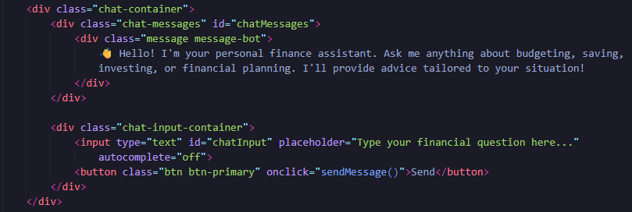

Milestone 4: Frontend UI Development
- Activity 4.1: Build HTML/CSS/JS Pages for Core Screens
- Create dedicated pages for each feature: Implement index.html (Dashboard), chat.html, budget.html, insights.html, and settings.html to keep navigation simple and user flows focused.
- Ensure responsive, mobile-friendly layout: Use flexible layouts and media queries so pages look good on laptops, tablets, and phones, without needing heavy frontend frameworks.
- Apply consistent visual style: Use a shared styles.css file for fonts, cards, buttons, and charts to keep the visual identity clean and uniform across all pages.

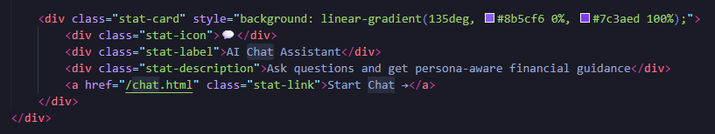

- Activity 4.2: Implement Form Handlers and API Integrations with Fetch
- Capture user input from forms and dynamic tables: In app.js, read values from inputs such as income, expenses, categories, and goals to assemble complete client-side data objects.
- Convert inputs into API-ready JSON payloads: Build structured JavaScript objects and send them to backend endpoints using fetch() with proper headers and error handling.
- Handle loading states and errors gracefully: Display simple loaders and inline error messages when API calls fail or take too long, improving user experience and trust.

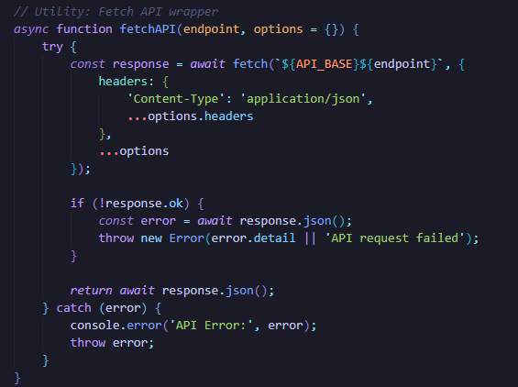

- Activity 4.3: Render Responses as Summary Cards, Tables, and Charts
- Update DOM dynamically with result data:
Insert totals, savings rate, and recommendations into cards and text containers on success responses.
- Generate visual charts with Chart.js:
Use the returned category percentages and top categories to render doughnut or bar charts, helping users quickly understand their spending patterns.
- Display red flags and suggestions clearly:
Highlight risk areas (e.g., overspending) in different colors or sections so users can immediately see where action is needed.

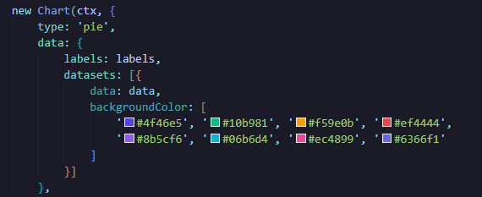

- Activity 4.4: Format All Currency Output to INR Using Intl.NumberFormat
- Create a reusable INR formatter in JavaScript:
Define a function using new Intl.NumberFormat('en-IN', { style: 'currency', currency: 'INR' }) to standardize how rupee values appear.
- Apply the formatter to all displayed amounts:
Ensure income, expenses, and recommendations all appear with the ₹ symbol and Indian comma formatting throughout the UI.
- Maintain a consistent money experience:
Verify that no raw numbers slip through unformatted, providing users with a localized and professional-looking interface.
Frontend Folder:
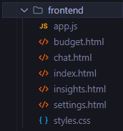

Milestone 5: Deployment
- Activity 5.1: Set Up Production Deployment for Backend and Static Frontend
- Prepare production-ready server configuration: Containerize the FastAPI app (optional) or deploy it to a platform like Render or Railway with uvicorn as the ASGI server.
- Host static frontend assets separately or together: Serve HTML/CSS/JS either from the same FastAPI app (via static files) or from a static hosting service while pointing them to the backend API URL.
- Verify environment-specific behavior: Test that APP_ENV=prod correctly activates real Granite and Groq clients, while local mode continues using the mock LLM.

- Activity 5.2: Configure Secure Environment Variables for Groq and Granite
- Set secrets in hosting provider’s environment panel: Add keys like GROQ_API_KEY, GROQ_API_URL, OLLAMA_API_URL, and GRANITE_MODEL_NAME using secure secret management interfaces.
- Avoid exposing secrets in client code or logs: Confirm that no credentials are referenced in frontend JavaScript or accidentally printed in logs or error messages.
- Document configuration for future maintenance: Update README with clear instructions on which variables are required for each environment to simplify onboarding and troubleshooting.

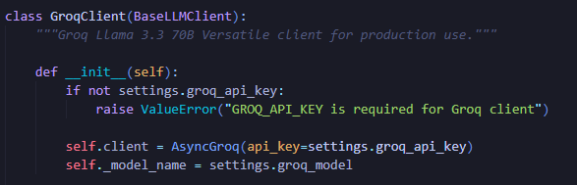

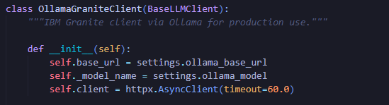

- Activity 5.3: Optimize Performance with Streaming, Timeouts, and Caching
- Add reasonable timeouts to LLM calls: Configure HTTP client sessions so requests to Groq and Granite fail gracefully when exceeding a certain duration, avoiding stuck responses.
- Enable streaming where appropriate: For chat responses, optionally consume streamed tokens from Granite to improve perceived responsiveness.
- Cache reusable configuration and model clients: Use techniques like lru_cache for client initialization so repeated calls reuse the same connection settings, reducing overhead.

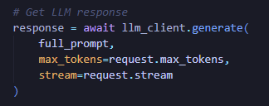

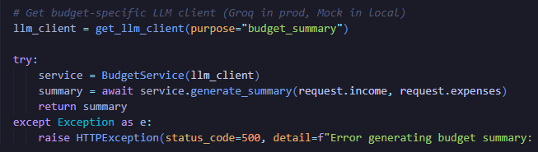

- Activity 5.4: Final Testing with Mock, Local, and Production Modes
- Test full flow using mock model in local mode: Run through all pages (chat, budget, insights) with APP_ENV=local and verify UI behaviors, API contracts, and error handling.
- Run integration tests against real services in controlled environment: Temporarily point to real Granite and Groq endpoints and confirm that outputs follow the expected JSON schemas and formats.
- Validate user experience and documentation: Check that instructions, environment switching, and feature flows are clear for future operators and users before marking the system ready.
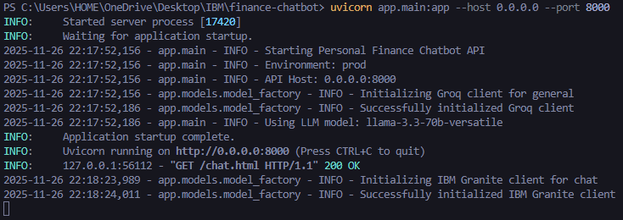

Exploring Website’s Web Pages:
Dashboard:
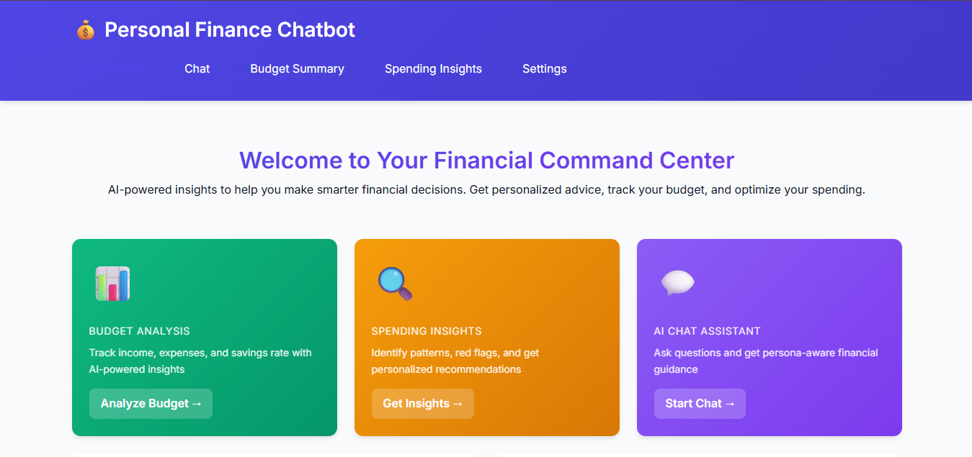
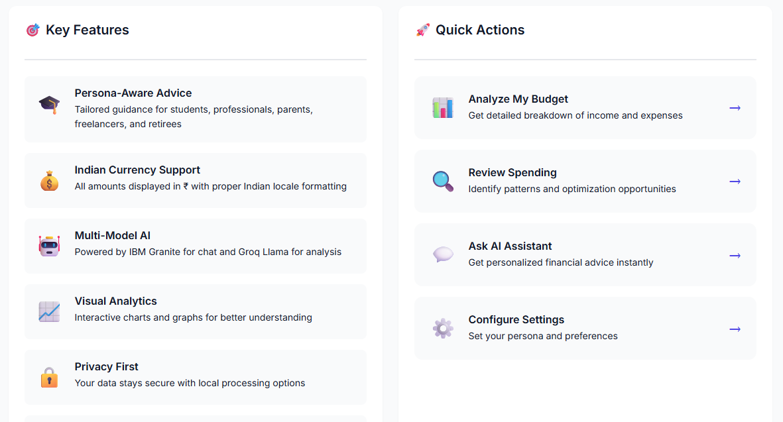

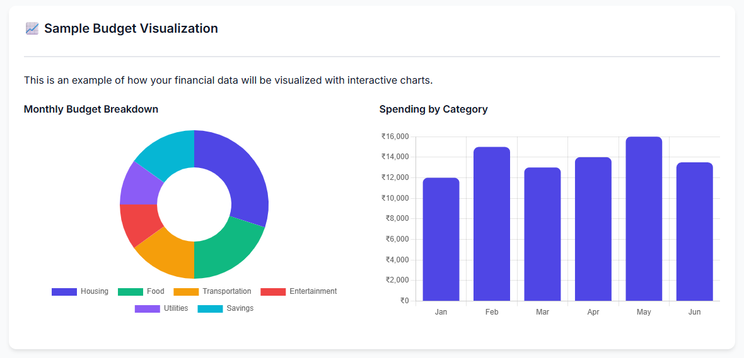

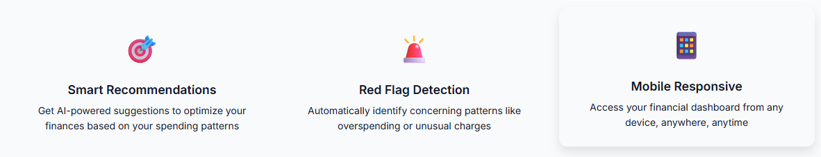

Finance Chatbot:
Input for chat:
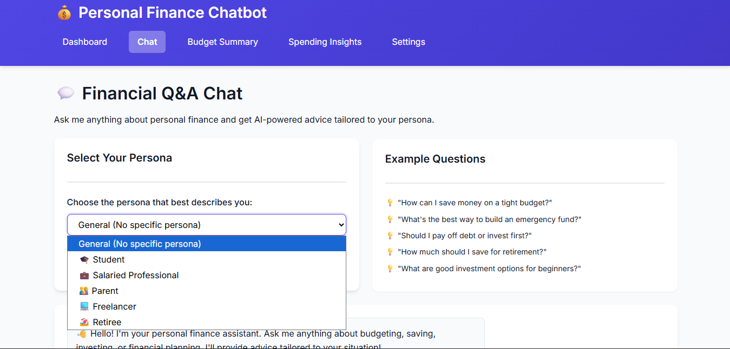

Output generated:
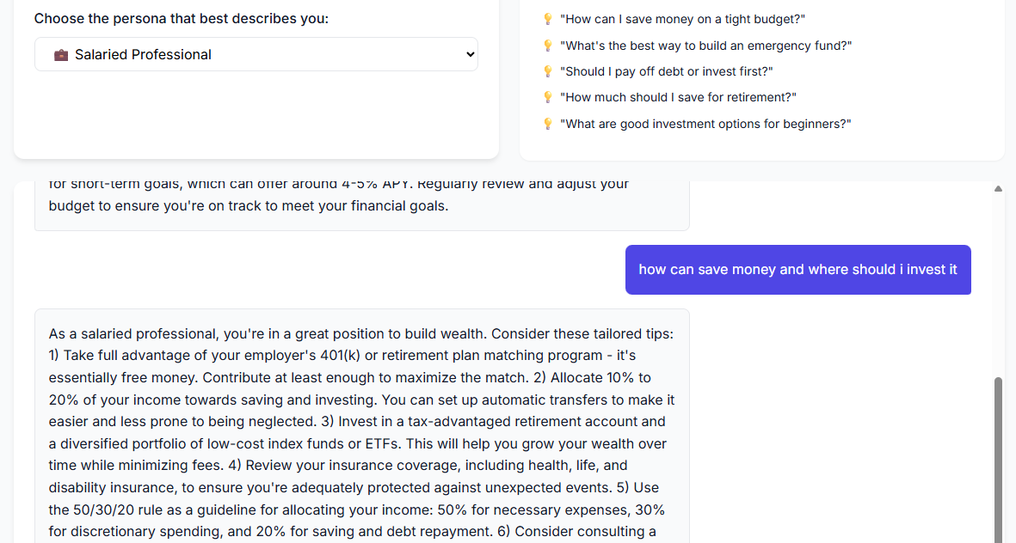
Description: The chatbot provides personalized financial guidance through natural, conversational interaction. Powered by IBM Granite, it adapts responses based on user persona such as student or working professional, making advice relatable and practical. Users can ask general finance questions, request saving tips, or seek help planning goals like buying a laptop or building an emergency fund. The chatbot responds in simple language, offers step-by-step suggestions, and avoids complex jargon. It also maintains an empathetic tone, ensuring users feel supported while improving their financial decisions.

Budget Summary:
Input for Budget Summary:
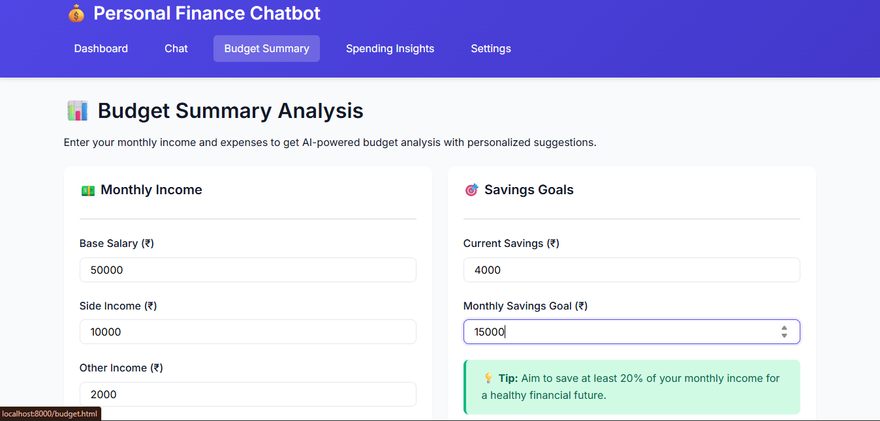

Monthly Budget:
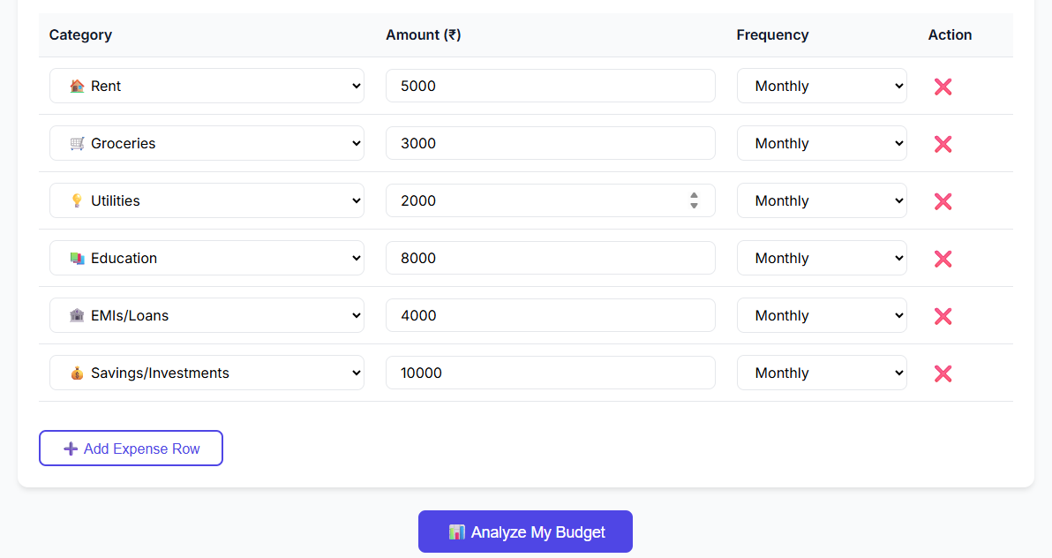
Output for Budget Summary:

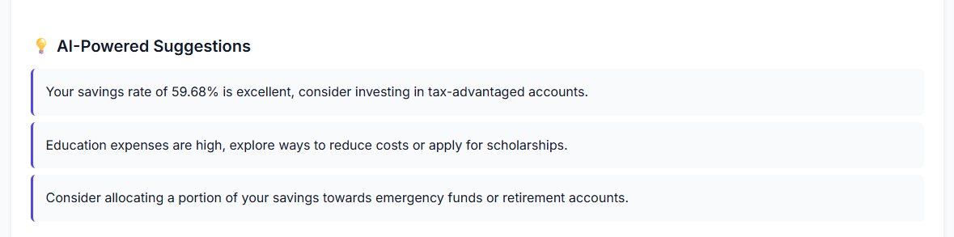

Description: The Budget Summary provides a clear picture of the user’s monthly finances by analyzing total income, expenses, and savings potential. Using form-based inputs, it automatically categorizes spending and calculates how much money is being saved or overspent. Powered by Groq analytics, the system presents accurate breakdowns, percentage-wise charts, and category insights in Indian Rupees (₹). It highlights major spending areas and identifies where adjustments can improve savings. The summary also offers personalized suggestions to help users optimize their monthly budget and plan smarter financial decisions.

Spending Insights:
Analysis Period:
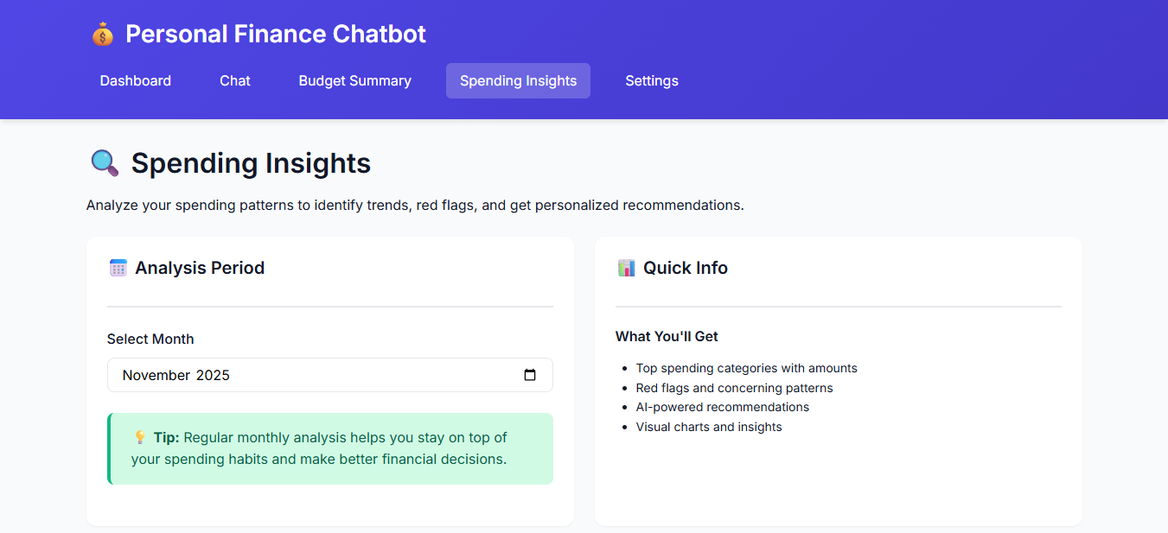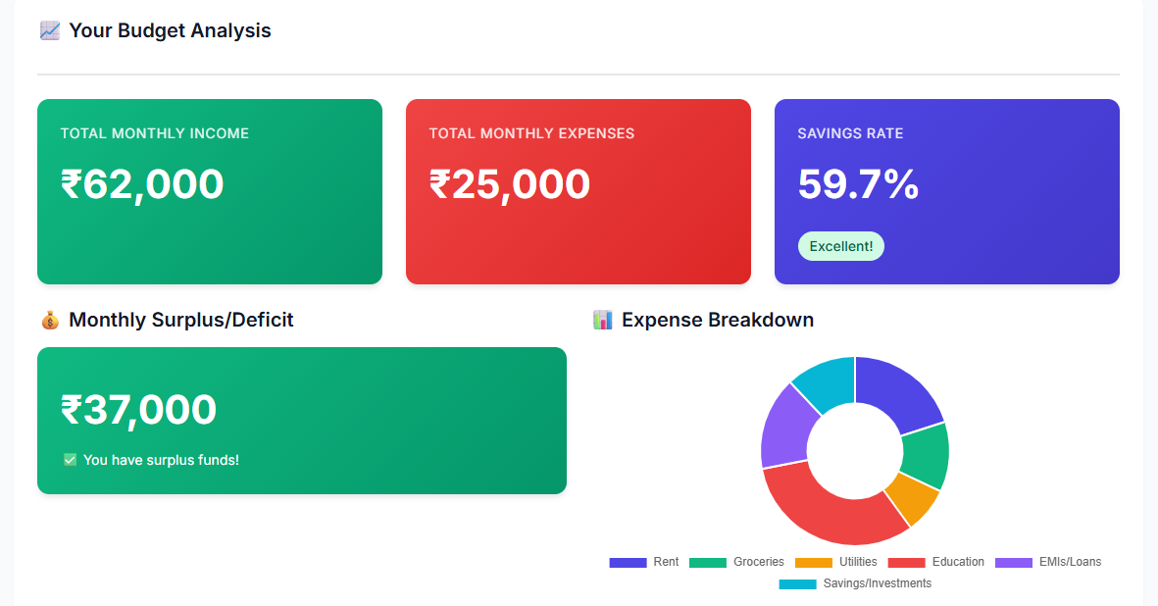
Spending Breakdown:
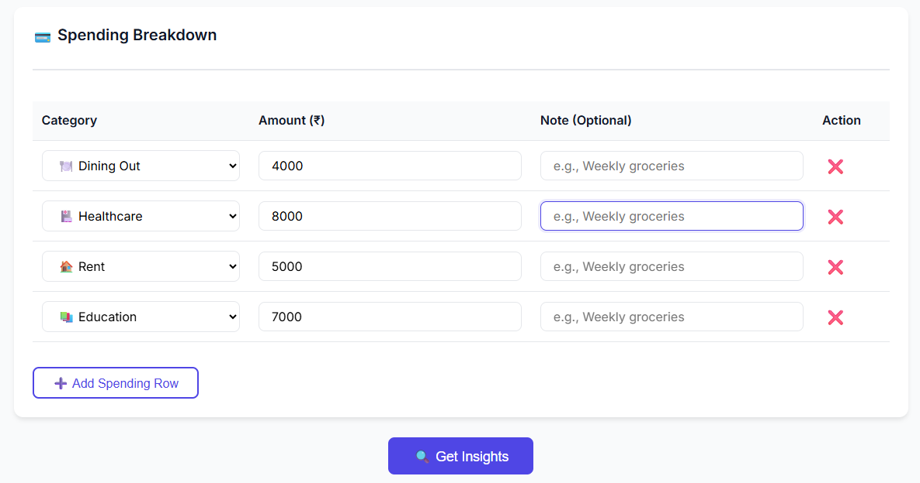

Analysis:
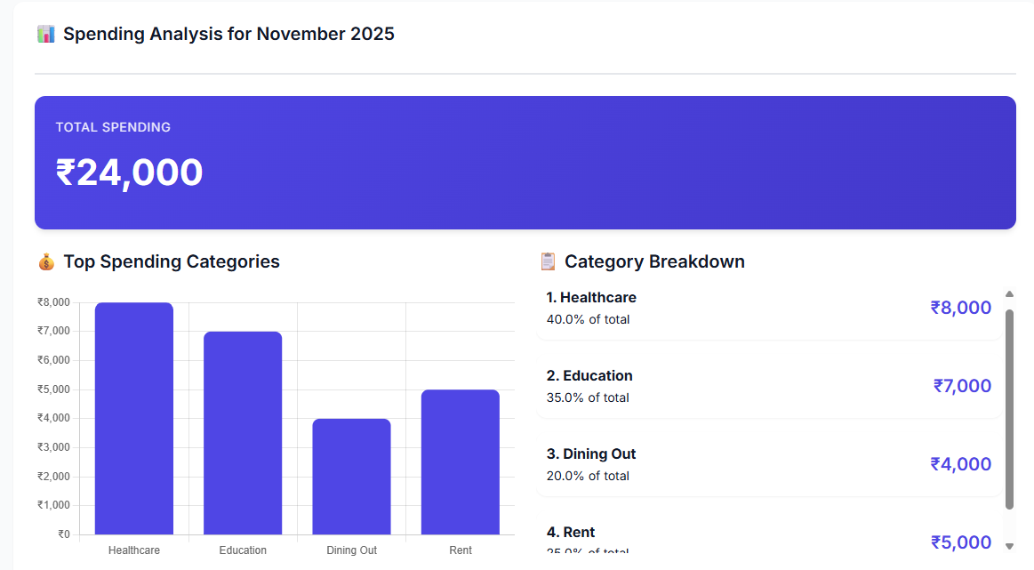
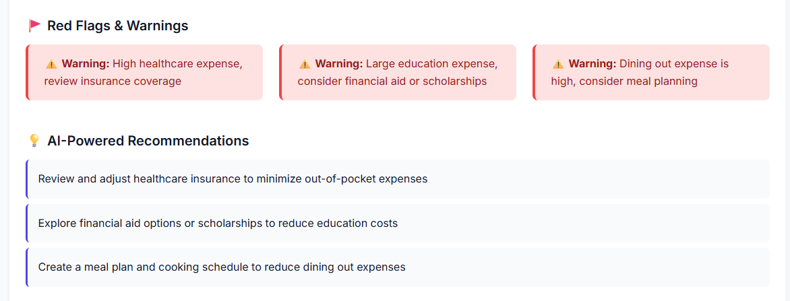
Description: The Spending Insights module helps users understand where their money is being spent and how it impacts overall financial health. By entering daily or monthly expenses through a dynamic form, the system categorizes spending into groups such as food, rent, shopping, travel, and UPI transactions. Groq-powered analytics detect red flags like overspending in specific categories or imbalanced needs vs wants. Visual charts highlight top expense areas, while recommendations suggest practical ways to reduce unnecessary costs. These insights help users become more aware of their spending behavior and make smarter financial adjustments in Indian Rupees (₹).

Settings & Configuration:
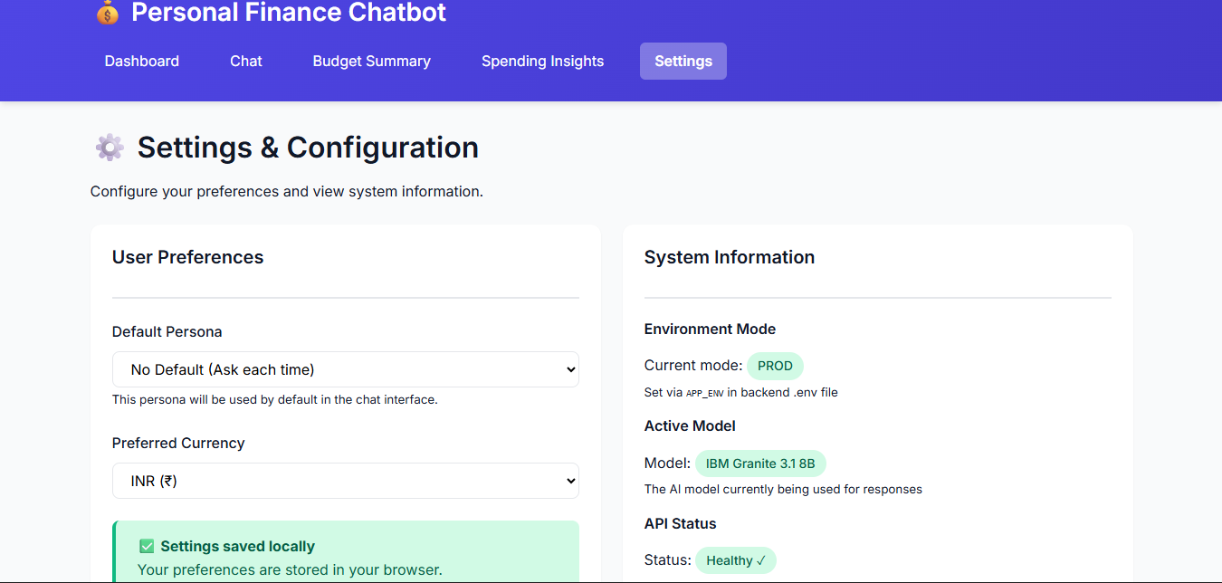
Persona Selection:
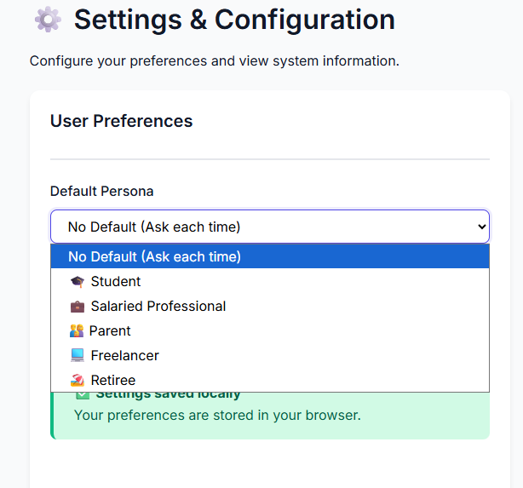
Currency Selection: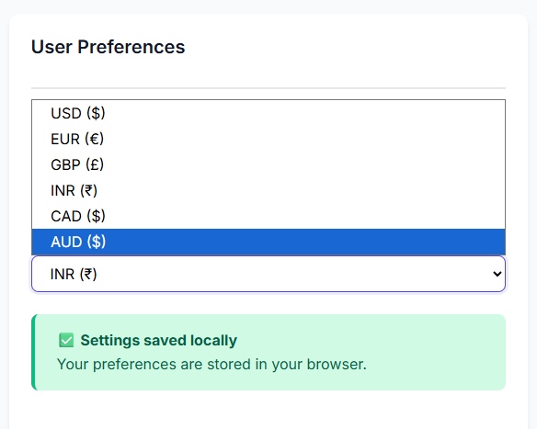
System Information:
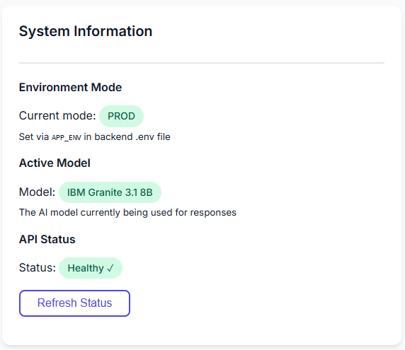
Persona Descriptions:
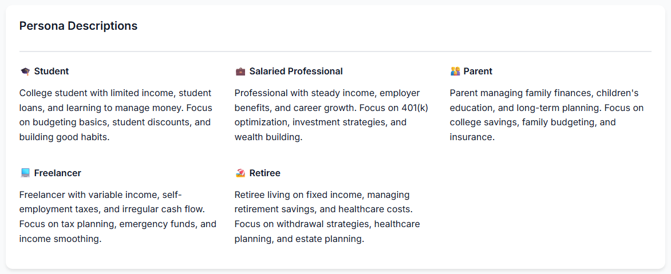

About this Application:
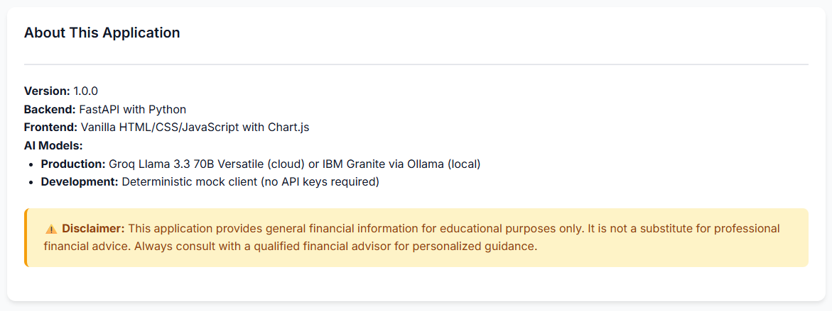

Description: The Settings page allows users to personalize their financial experience by choosing their persona, such as student or working professional, which influences how the chatbot provides advice. It displays the current application mode (local or production), making it clear whether responses come from the mock model or real AI. Users can also view and update optional configuration fields for development purposes without exposing sensitive keys in the frontend. The page ensures a customized and transparent user experience, helping the system deliver more suitable and realistic financial recommendations. Overall, it provides better control over how the application behaves and responds to user needs.

Conclusion:
The Personal Finance Chatbot project successfully delivers an intelligent and user-friendly platform that guides individuals in making smarter financial decisions. By combining conversational assistance with structured financial analytics, the system bridges the gap between complex budgeting concepts and everyday users who may lack financial expertise. Through a simple web interface and form-based inputs, users can easily analyze their spending, understand budgeting outcomes, and receive saving strategies without dealing with raw data or technical formats. This ensures accessibility for a wide audience, from students managing pocket money to working professionals planning monthly expenses.
A major strength of this solution lies in its dual-model architecture, where IBM Granite powers empathetic and persona-aware conversations, while Groq handles precise budget and spending computations. This separation ensures that the chatbot provides natural, relatable advice without compromising the accuracy of financial insights. Additionally, the system’s INR-specific formatting and locally relevant recommendations make it especially useful within the Indian financial context. The fallback mock model further enhances development flexibility by allowing smooth testing on low-spec devices without requiring costly external calls.
The project also emphasizes transparency, security, and scalability. Environment variables prevent sensitive information from leaking, structured JSON prompts reduce model hallucination, and modular routing makes future integration of new models or features effortless. Frontend clarity is prioritized through well-designed charts, summaries, and responsive interfaces, elevating user experience while maintaining trustworthy data presentation.
Overall, this project represents a significant step toward practical, AI-assisted personal finance management. It demonstrates how conversational AI and financial analytics can complement each other to create a dependable financial advisor that is easy to use, context aware, and technically robust. With future enhancements such as live bank integration, mobile apps, or advanced personalization, the system has the potential to evolve into a full-scale financial companion that empowers users to build sustainable financial habits with confidence.

